ASSIGNMENT
JAYSHREE SHINDE
- Get total population of each country by continent



- Second largest country by area



- Find the name of whose population is greater than the avg population of all cities in city table.



- Rank countries by population separately for each continent using window function.

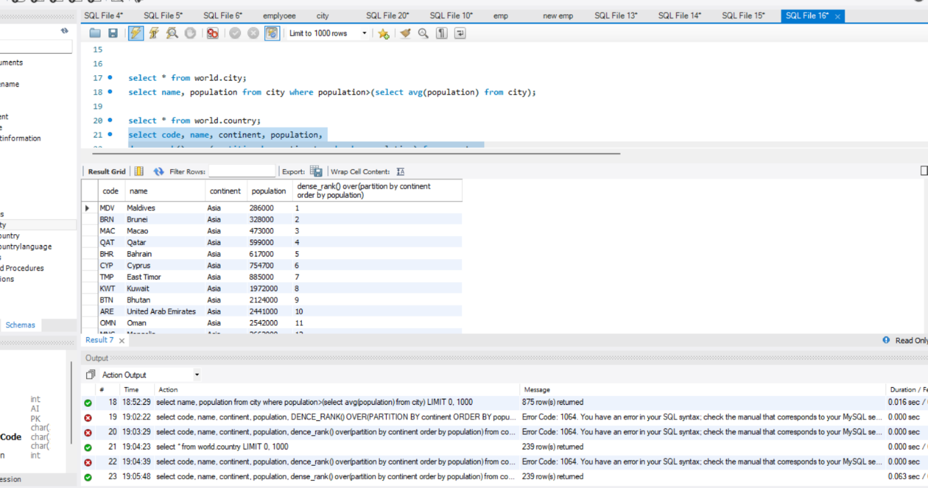

- Find the second highest populated city using window function.



